[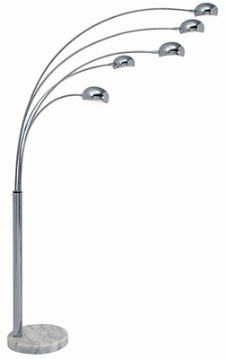](https://www.google.fr/url?sa=i&rct=j&q=&esrc=s&source=images&cd=&cad=rja&uact=8&ved=2ahUKEwipuJyg1oHhAhXD1eAKHXkxCvUQjRx6BAgBEAU&url=http%3A%2F%2Fwww.celmakie.fr%2Flampadaire-5-branches-fly%2F&psig=AOvVaw0TZAQmkqWGW47ugGrylIDE&ust=1552654329203318)