**Urban 3.0 Service Manual**

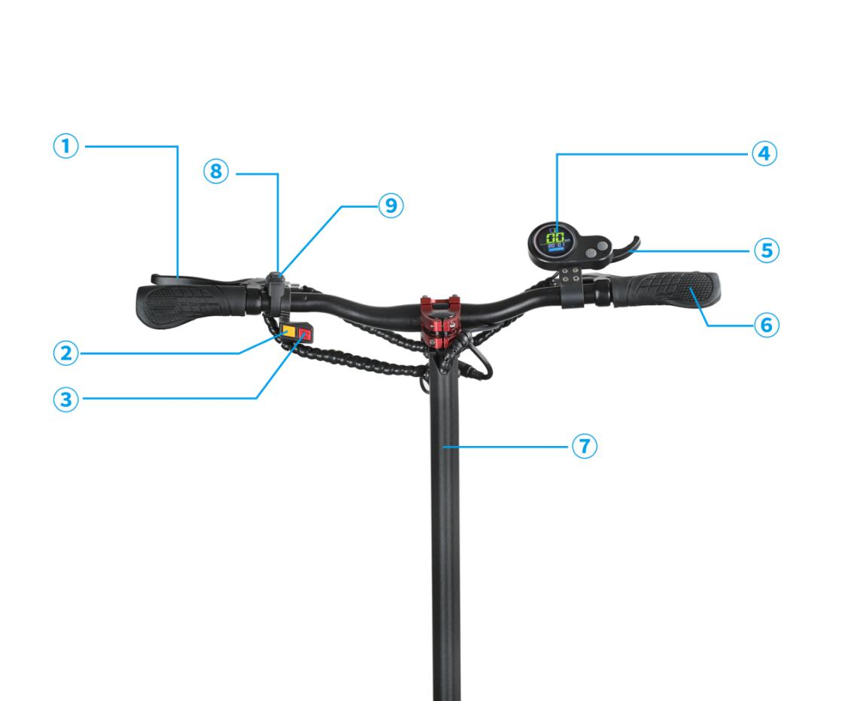

1. Brake
2. Front Light
3. Dual Motor Switch
4. Display
5. Accelerator
6. Handlebar
7. T Tube
8. Horn
9. LED Light

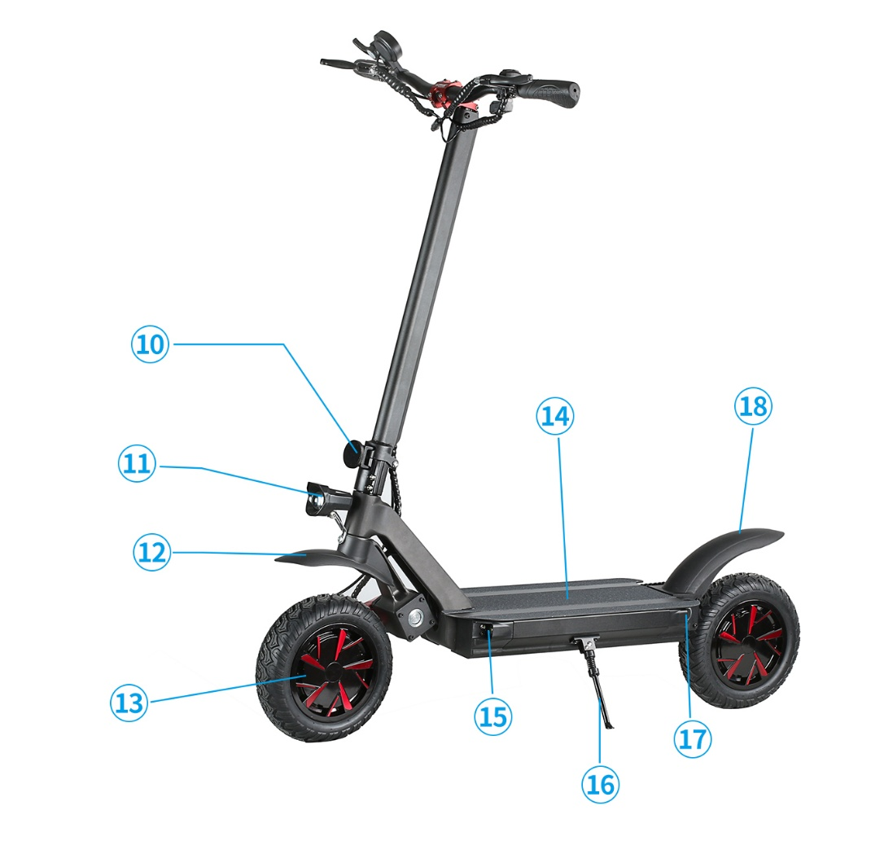

1. Folding connection part
2. Front Light
3. Front Fender
4. Motor
5. Pedal
6. Front LED Light
7. Stand
8. Rear Light
9. Rear Fender

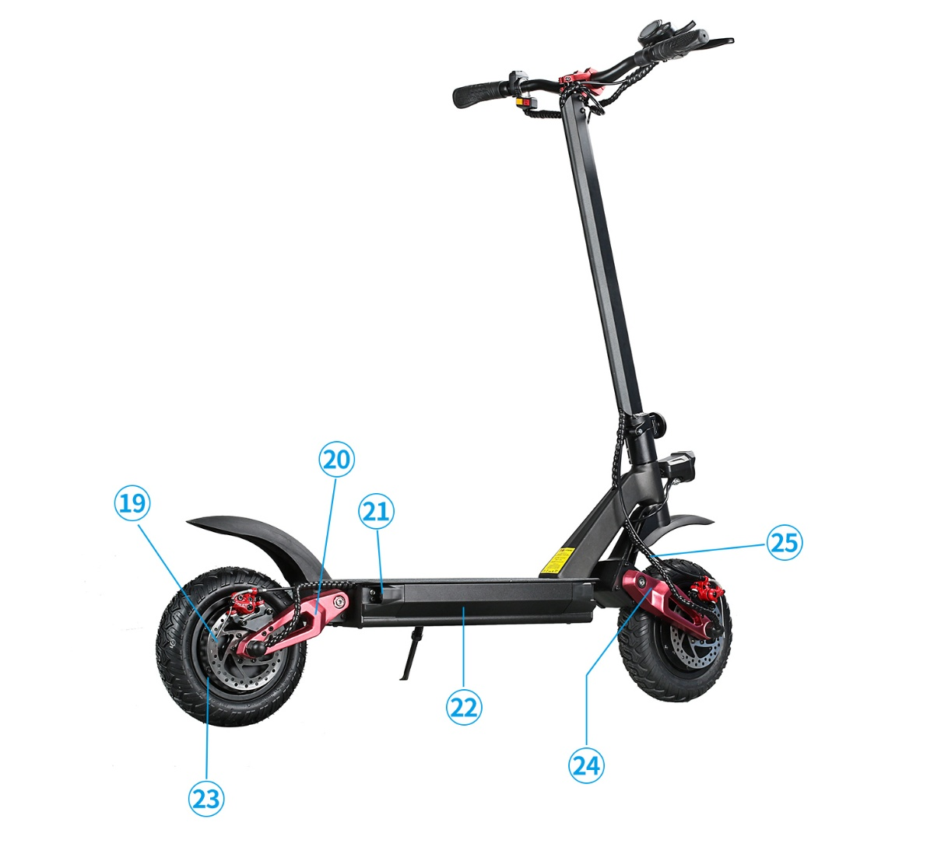

1. Rear Disc
2. Rear Swing arm
3. Rear Light
4. Body case
5. Aluminum Alloy Wheel Hub
6. Front Swing arm
7. Motor Wire

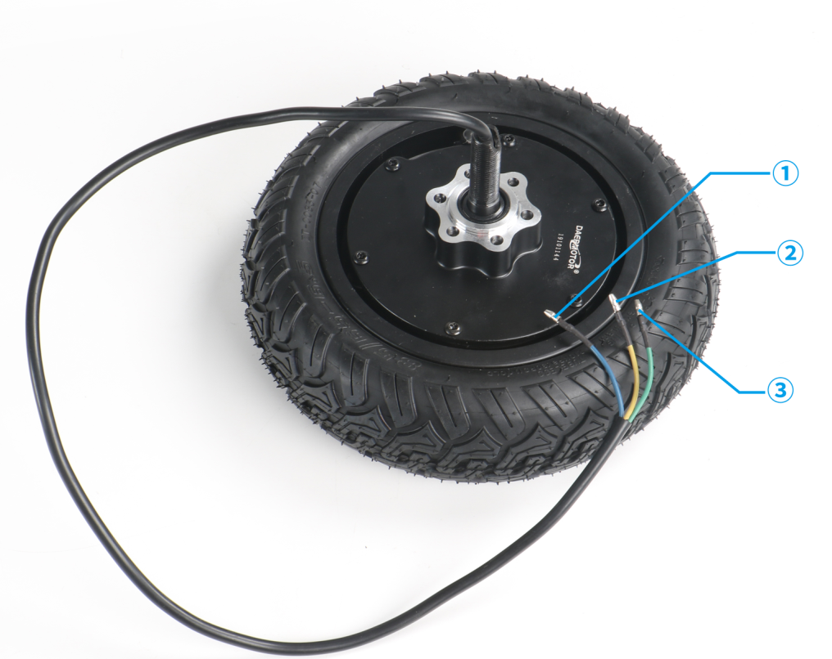

The lines of 1(Bule) and 3(Green) which are the power cable of the motor  
The lines of 2(Yellow) for Signal Output

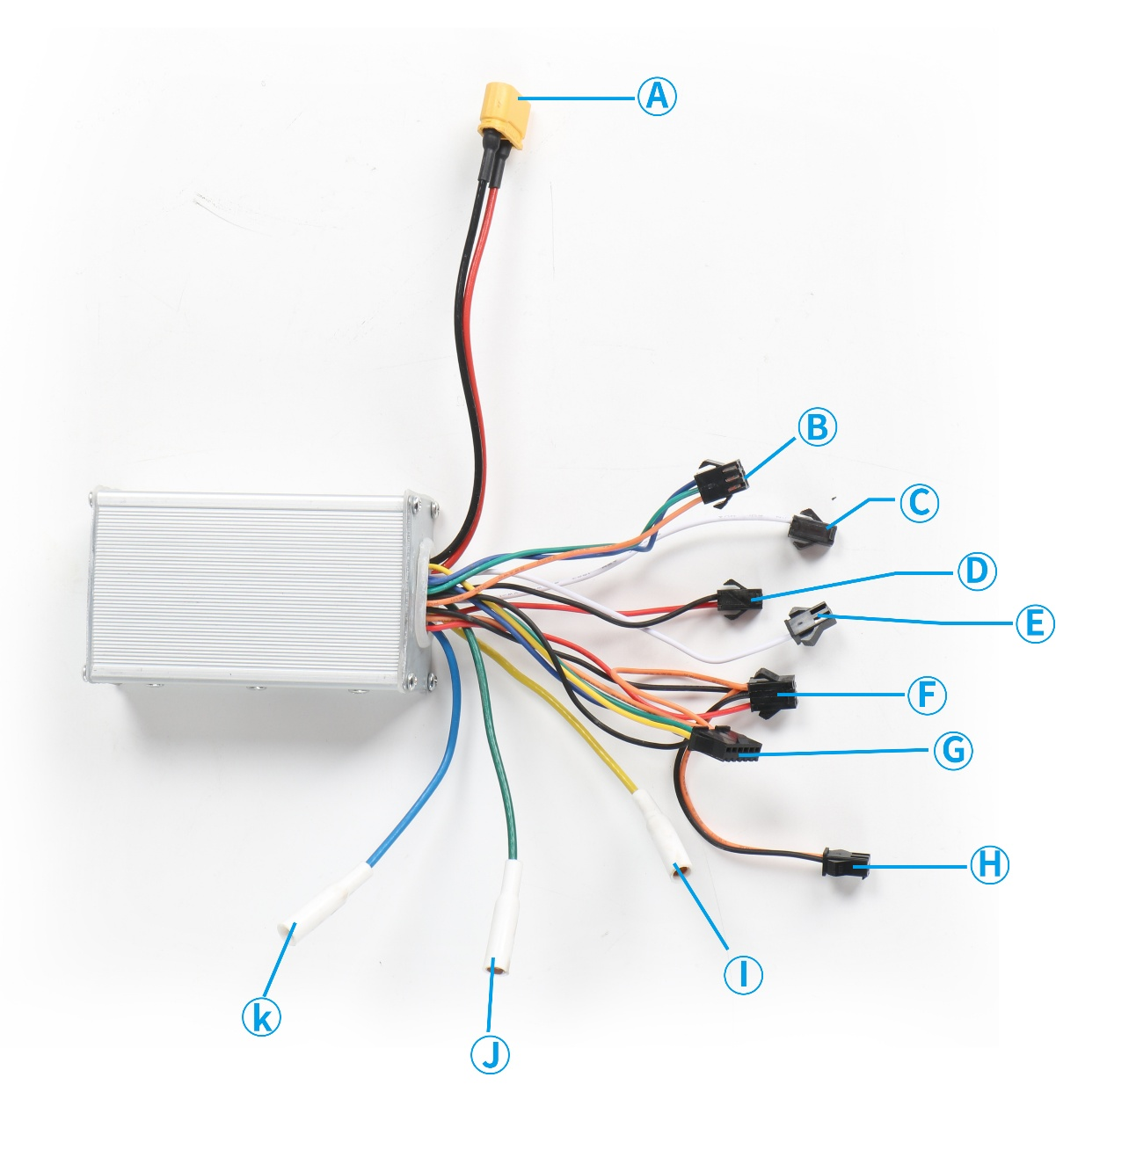

1. This group has 2 thick lines which are thecable of the battery(connect with battery)
2. This cable is single and dual motor switching lines
3. Brake Hall signal light cable
4. This cable is spare line, not used in this product
5. Brake Hall signal light cable
6. Alarm for power Line
7. This cable control the display of this e-scooter
8. LED Light for power Line
9. J. K. Power Cable of the Motor

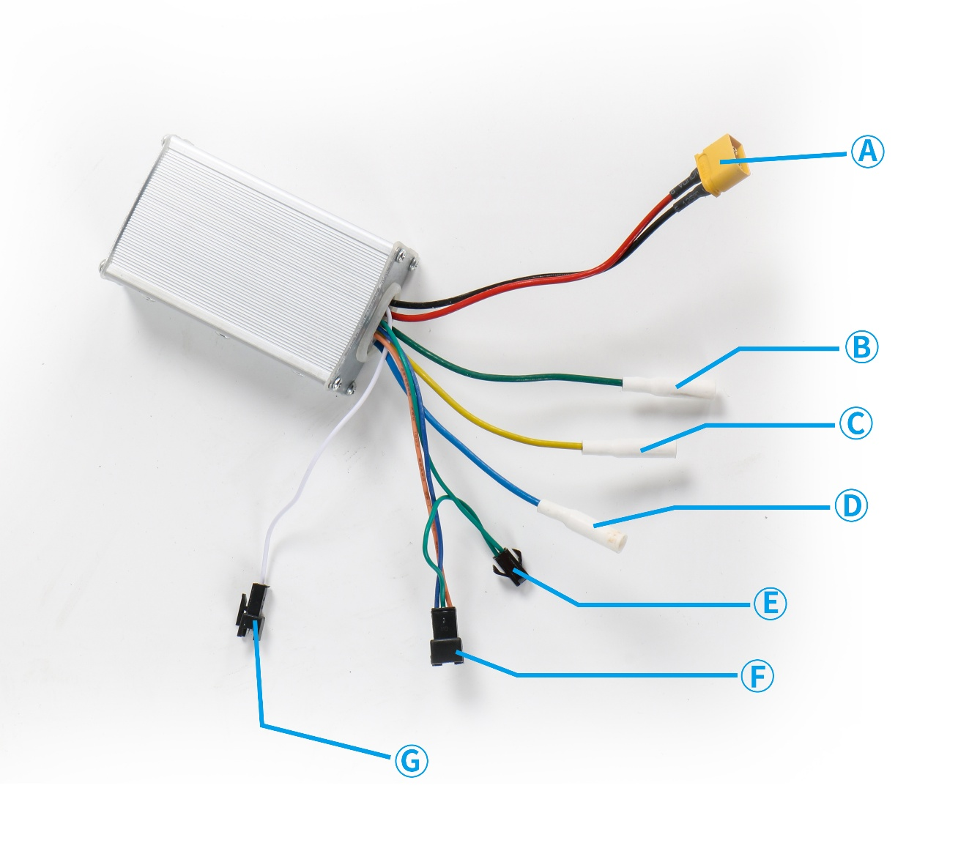

A.This group has 2 thick lines and yellow connector which are the power cable of the battery(connect with battery)

B. C. D. Power Cable of the Motor

E. Single and double drive switch switching line

F. Brake Hall signal light cable

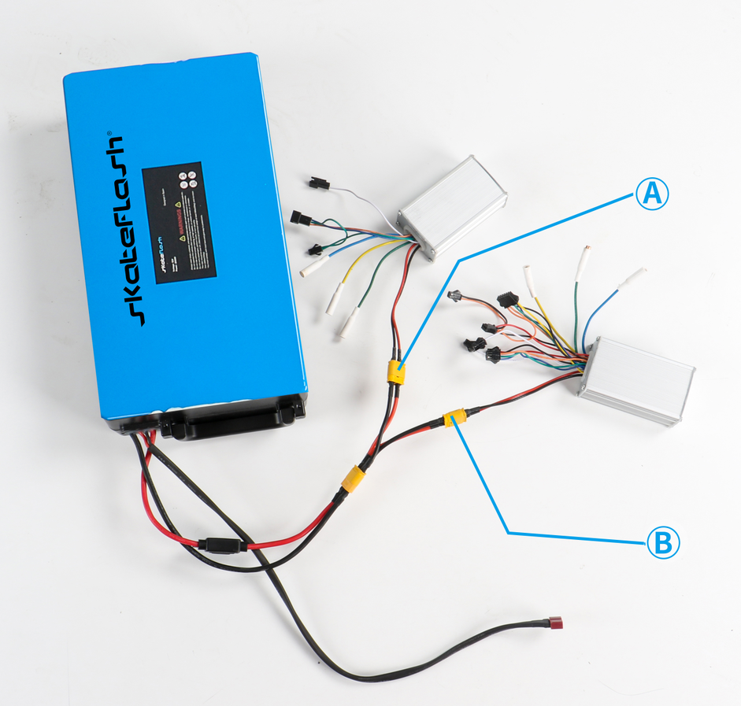

1. B. Power connector

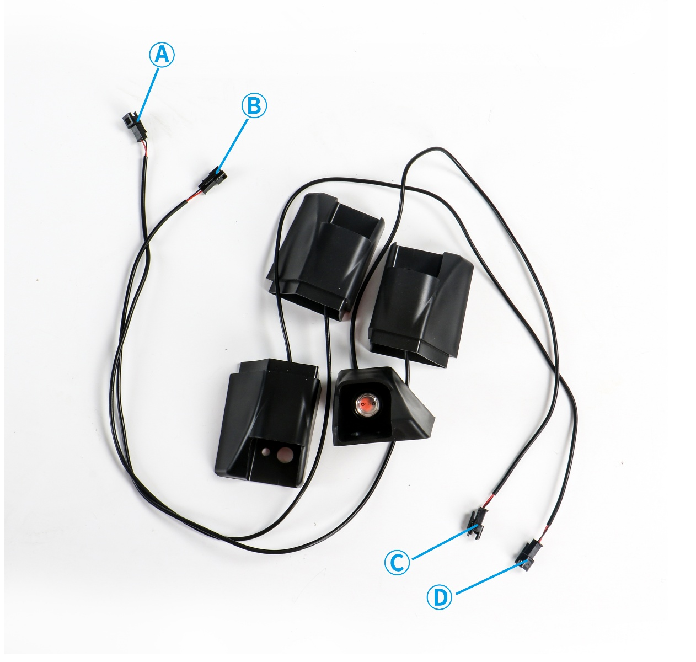

1. B. C. D. LED Light Power Line

Integrate Line as following:

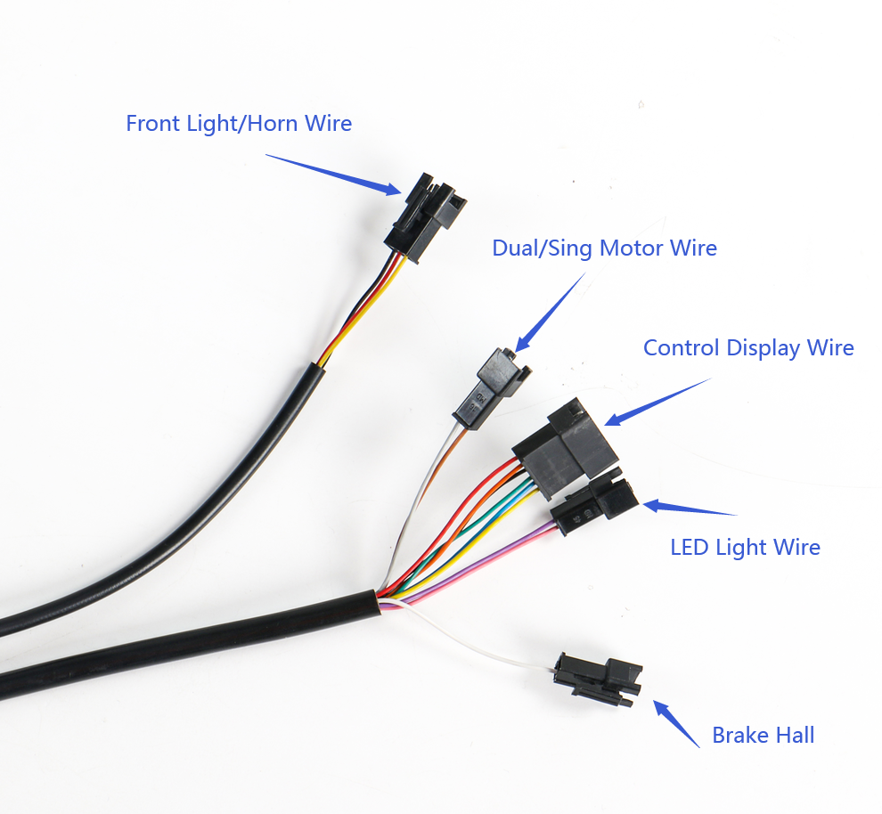

All wire connection as following:

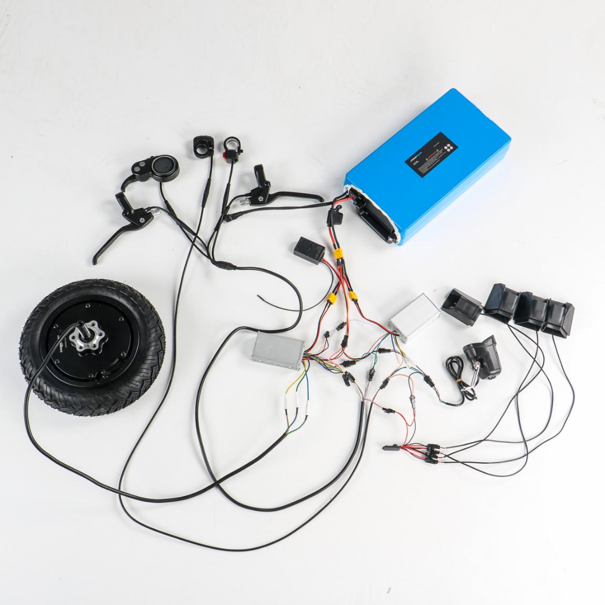

Display function

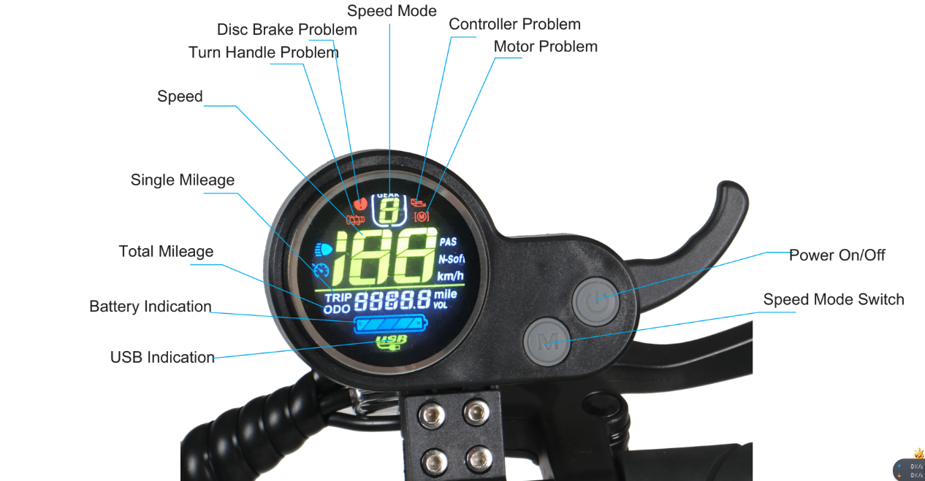

There are two buttons on the Display, which are Power button and Function button.

After Power on,the Display will show Battery,Speed and Speed model and so on.

Press Power button a few seconds to turn on or off the power.

Display will power off if the scooter remains no signal in three minutes

Press the power button shortly when the power on,display will show TRIP,ODO,VOL by

turn, 00:00 means time, TRIP means DST trip distance.ODO means accumulated distance.VOL

means battery voltage.

Press the speed button shortly,three kind speed mode (Beginner Mode and Normal

Speed Mode,High speed mode) will be switched by turn.

Press the speed button a few seconds,DST trip distance will be reset to zero.

Press the accelerate to increase the speed; loosen the accelerate to slow down.

When the scooter is turned on, long press this button  again to turn off the power.

Parameter setting

Long press this button and at the same time,enter the setting interface. And then press this button , it will show P0,P1,P2,P3,P4,P5,P6 and P7.

P0 wheel diameter setting

P1 under voltage point setting

P2 magnetic pole pair setting

P3 speed signal selection setting

P4 km and mile selection

P5 non-zero start and zero start selection setting

P6 cruise control function setting

P7 Soft and power start setting

After the setting is completed, press this button to save the setting and then it will automatically return to the original display interface.

When the electric scooter fails, the meter will display the faulty parts, such as 12Disc Brake Problem, 电机Motor problem,转把Turn Handle Problem,控制器Controller problem